C. Even Picture
time limit per test
2 seconds
memory limit per test
512 megabytes
input
standard input
output
standard output
Leo Jr. draws pictures in his notebook with checkered sheets (that is, each sheet has a regular square grid printed on it). We can assume that the sheets are infinitely large in any direction.
To draw a picture, Leo Jr. colors some of the cells on a sheet gray. He considers the resulting picture beautiful if the following conditions are satisfied:
- The picture is connected, that is, it is possible to get from any gray cell to any other by following a chain of gray cells, with each pair of adjacent cells in the path being neighbours (that is, sharing a side).
- Each gray cell has an even number of gray neighbours.
- There are exactly nn gray cells with all gray neighbours. The number of other gray cells can be arbitrary (but reasonable, so that they can all be listed).
Leo Jr. is now struggling to draw a beautiful picture with a particular choice of nn. Help him, and provide any example of a beautiful picture.
To output cell coordinates in your answer, assume that the sheet is provided with a Cartesian coordinate system such that one of the cells is chosen to be the origin (0,0)(0,0), axes 0x0x and 0y0y are orthogonal and parallel to grid lines, and a unit step along any axis in any direction takes you to a neighbouring cell.
Input
The only line contains a single integer nn (1≤n≤5001≤n≤500) — the number of gray cells with all gray neighbours in a beautiful picture.
Output
In the first line, print a single integer kk — the number of gray cells in your picture. For technical reasons, kk should not exceed 5⋅1055⋅105.
Each of the following kk lines should contain two integers — coordinates of a gray cell in your picture. All listed cells should be distinct, and the picture should satisdfy all the properties listed above. All coordinates should not exceed 109109 by absolute value.
One can show that there exists an answer satisfying all requirements with a small enough kk.
Example
input
Copy
4
output
Copy
12
1 0
2 0
0 1
1 1
2 1
3 1
0 2
1 2
2 2
3 2
1 3
2 3
Note
The answer for the sample is pictured below:
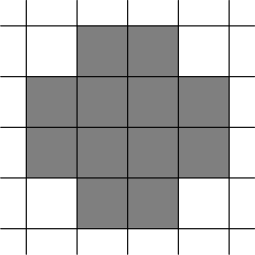

我菜啊，这样构造就完事了
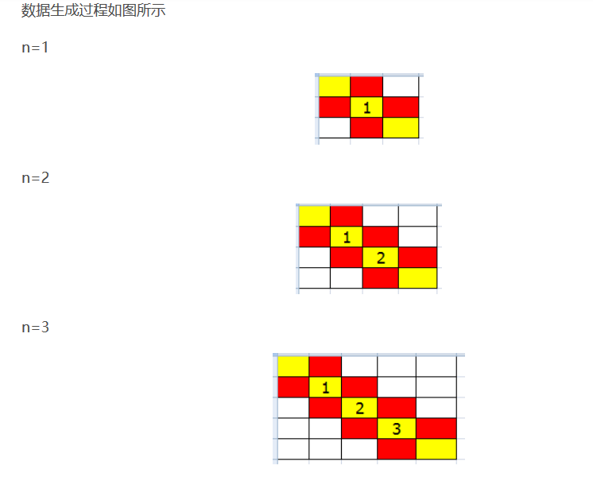

#include<bits/stdc++.h>
#define ll long long
using namespace std;
int main()
{
int n;
scanf("%d",&n);

ll ans=7+3*(n-1);
ll x=2;ll y=2;
printf("%lld\n",ans);
printf("0 0\n");
printf("1 0\n");

printf("0 1\n");
printf("1 1\n");
printf("2 1\n");

printf("1 2\n");
printf("2 2\n");
for(int i=2;i<=n;i++)
{
printf("%lld %lld\n",x+1,y);
printf("%lld %lld\n",x,y+1);
printf("%lld %lld\n",x+1,y+1);
x++; y++;
}

return 0;
}

